



John C. Rooney, P.E.

Commissioner of Public Works

Ron J. Pritzlaff, P.E.

Asst. Comm. of Public Works

Department of Public Works

City Hall

730
Washington Avenue

Racine, WI 53403

262.636.9121

–

Public Works

262.636.9191

-

Engineering

To Whom It May Concern:

Please find enclosed the Application for Special Solid Waste Collection that you requested. There are two sheets: one that must be completed by the applicant and another that must be completed by the applicant’s doctor.

Both forms must be returned to our office at the same time for the application to be processed.

If you have any questions regarding these forms, please feel free to contact our office at (262) 636-9171.

Sincerely,

John C. Rooney

John C. Rooney, P.E.
Commissioner of Public Works

Enclosures

Rev. 09/22

Special Solid Waste Collection Rules and Regulations

Eligibility

To be eligible for special solid waste collection, the householder must be disabled, handicapped, and/or elderly, with no one in the household physically able to carry the solid waste to the curb line for collection.

Application

A written application must be submitted to the Commissioner of Public Works and receive approval from the Commissioner of Public Works.

Material

Only domestic (household) waste will be collected from the back door. Recycling carts with acceptable recycling material will also be collected from the back door. Any other type of material must be properly prepared and placed at the curb line for collection.

Placement

Solid waste material for back door collection must be placed in the immediate area of the back door, but NOT on porches, stoops or inside garages. It must be easily accessible and unobstructed by cars, shrubbery and fences.

Collection

Collection will be made once a week on the regular collection day for that district. Waste must be ready for collection no later than 7:00 A.M. of the scheduled collection day.

Containers

There shall be a maximum of two (2) containers per dwelling unit per week. The containers of those eligible for special collection must be identified by address if the householder lives in a two to four-family unit building.

We promote the use of one-way disposable bags.

Questions

If additional information is needed regarding the special collection service, please call (262) 636-9103 between the hours of 7:00 A.M. and 2:30 P.M., Monday through Friday.

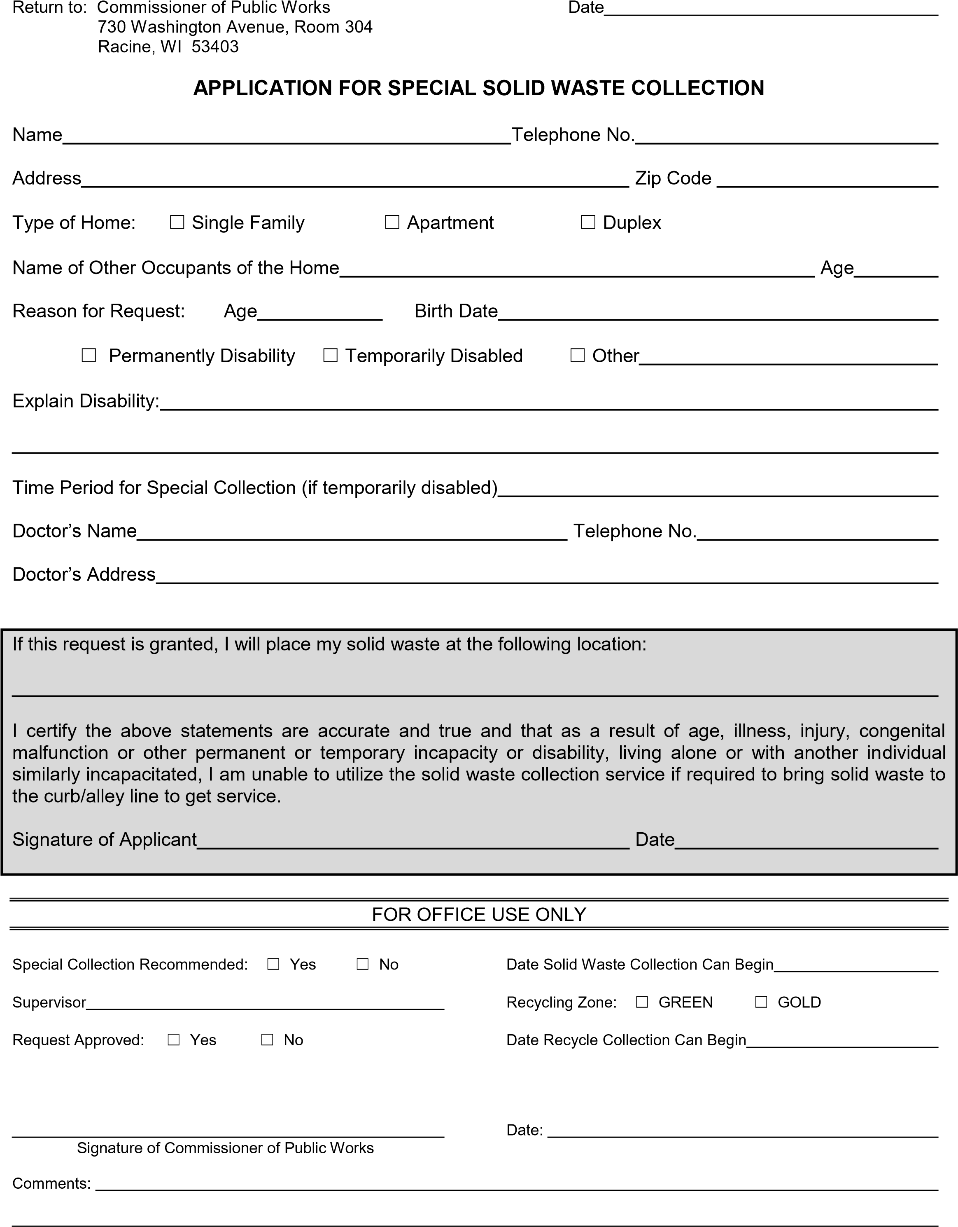


John C. Rooney, P
Yehlen, P
.
E
.

Commissioner of Public Works

Thomas M. Eeg, P.E.

Asst. Comm. of Public Works/Operations

Department of Public Works

City Hall

730
Washington Avenue

Racine, WI 53403

262.636.9121

–

Public Works

262.636
-

9191
–

Engineering

Dear Physician:

The City of Racine Department of Public Works requires all residents to place their solid waste and recyclables at the curb or alley line for collection. However, we do provide a “back door” service for those residents with disabilities or other medical conditions which prevent them from being able to comply with these rules.

The person identified below has requested this special collection service and has identified you as their physician. We do need to have you certify that the applicant’s condition prevents them from placing their solid waste and recyclables at the curb or alley line. We would appreciate your filling out this form and returning it by mail or fax (262) 636-9592, or email to kimberlyn.stafford@cityofracine.org.

Name of Applicant for Special Collection

☐ In my opinion, the patient’s medical condition prevents them from placing solid waste at curb/alley.

☐ The patient should not receive special collection.

Physician’s Name

Physician’s Signature

Date

